1. This is the 1st lecture on how to create Avro Object.
2. The following pom.xml configuration, we will talk in next lecture. Just Copy & Paste.  
   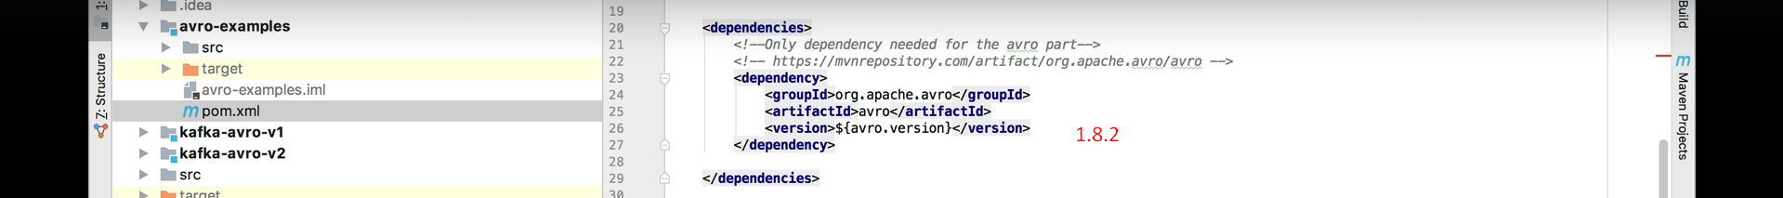  
     
   A computer screen shot of text

   Description automatically generated  
     
     
   A computer screen shot of text

   Description automatically generated
3. A close-up of a computer screen

   Description automatically generated
4. **Step 0**: **Define Schema**.  
   A screenshot of a computer

   Description automatically generated
5. **Step 1: Create a Generic Record**.  
    A close up of a text

   Description automatically generated  
     
   **Output**:   
     
     
     
   Let’s skip the setting of a field whose default value is defined in Schema.  
   A screenshot of a computer

   Description automatically generated  
     
     
   A close-up of a computer screen

   Description automatically generated